Module 09 – Fixed Charge Problem

Exploratory Data Analysis

*In this section, you should perform some data analysis on the data provided to you. Please format your findings in a visually pleasing way and please be sure to include these cuts:*

* *Make a visual graph of your data on a map (coordinates should be within US borders)*
  + <https://mymaps.google.com/>
  + Find a map with latitude/longitude and place them approximately
  + Any alternative that gives the same effect

Maroon is WH blue is DC

Model Formulation

*Write the formulation of the model into here prior to implementing it in your Excel model. Be explicit with the definition of the decision variables, objective function, and constraints.*

Minimize: 27.3X 11+8.78X 12+72.73X 13+33.95X 14+19.92X 15+61.02X 16+45.69X 2​1+64.81X 22+9.84X 2​3+34.18X 24+51.81X 25+2.39X 26+4.77X 31+27.77X 32+46.88X 33+34.18X 34+18.97X 35+43.31X 36+39.16X 41+67.34X 42+7.31X 43+36.71X 44+54.34X 45+8.92X 4 6

X 11+X 21+X 31+X 41 =1(Praline Park)

X 12+X 22+X 32+X 42 =1(Peppermint Parlor)

X 13+X 23+X 33+X 43=1(Meringue Mountains)

X 14+X 24+X 34+X 44=1(Licorice Lanes)

X 15+X 25+X 35+X 45=1(Pudding Peaks)

X 16+X 26+X 36+X 46=1(Snickerdoodle Slopes)

Model Optimized for Min Costs to Supply DCs

*Implement your formulation into Excel and be sure to make it neat.

* *A screenshot of your optimized final model (formatted nicely, of course)*
* *A text explanation of what your model is recommending*

They fully cover the demand for all the destination areas.

This solution keeps the total cost or deviation (74276.3) minimized or optimized.

Model with Stipulation

*Please copy the tab of your original model before continuing with the next part to avoid messing up your original solution.*

*Please perform 2 out of the 3 scenarios below with a short text description on what changed:*

1. *Instead of only being able to open 2 warehouses, what happens to our objective function when we only can open 1 warehouse? No single warehouse can fulfill all demand. If you must use only 1 warehouse, you’d need to Increase its capacity, Reduce demand ,Allow partial fulfillment (relax full-demand constraint)*
2. *Right now, we have $1 per unit shipped over the distance between the warehouse and the DC. What happens to our objective function when we increase this to $30? Does your DC assignment change at all?*

*Objective function increases dramatically by roughly 30× on the transportation portion. If other DCs are significantly closer to major demand points, they could be used to cut transport costs. You may go from using 2 DCs → 3 or more if opening a closer DC offsets shipping cost.*

1. 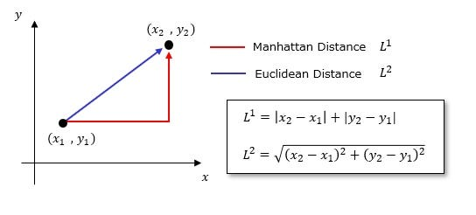*For distance between each location, we used Manhattan distance but what happens to our model if we use Euclidean distance instead? Did the change impact the model at all? Do you feel this is a better distance metric to use in this scenario?*